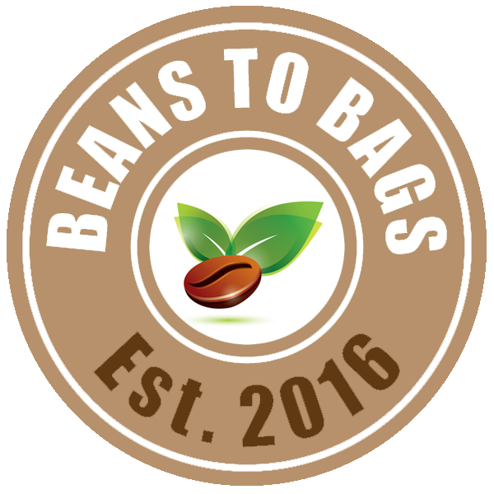

BEANS to BAGS EARN YOUR WAY
www.beanstobags.org

Earn Your Way
Avondale Middle School has partnered with Beans to Bags to create a unique way to help AMS Student earn their way on The Washington DC field trip. The Washington DC field trip is an outstanding experience that we would like to see participation for everyone.
Beans to Bags
Beans to Bags Roasting Company is a non-profit 501c(3) company run by Avondale High School students. The Beans to Bags coffee has superior flavor due to the high quality Arabica beans that are freshly roasted. Beans to Bags purchases green coffee beans, roasts the coffee at Avondale High School, and delivers the freshly roasted coffee to our customers within the peak freshness period. The hand signed bags with a roasting date signify quality and freshness.

Beans to Bags mission is to provide freshly roasted coffee from our roaster to our customer. In addition, we understand and value the importance of giving back to our community. 100% of the profits from Beans to Bags go to support Avondale youth in providing food and clothing for students in need, providing scholarships for those who participates in the entrepreneurship programs, and providing enrichment opportunities for students to go above and beyond.
How Does It Work?
Beans to Bags offers 3 types of coffee - Sumatra, Colombian, and Brazilian. Each bag retails at $12.00 for 12 oz bag. For every bag of coffee a student sell from May 15, 2017 through July 31, 2017, the student will earn $5.00 towards the payment to the Travel Company. Each student will complete a weekly order form and submit it to Beans to Bags by Thursday to ensure delivery to the customer by Monday. Students will need to pick-up their orders at Avondale High School and deliver orders to their customers.

Each student will need to set a goal of total amount he/she needs to earn to pay for the fieldtrip. If the student earns more than their goal, the student is given options on the Student Information Form on how this additional money can be used.

How much can you earn?
A typical coffee drinking family will consume 1 bag of coffee per week. This means, if a student only sells 1 bag of coffee per week from January 1st through May 13th (15 weeks), the student can earn $75 ($5 x 15 weeks).

If you are interested in participating in this fundraising opportunity, please fill out the Beans to Bags Earn Your Way Student Form and submit it to AMS by January 1st via Google Drive

If you have any questions regarding Earn Your Way, please contact Bonnie Kakuda at bonnie.kakuda@beanstobags.org.

