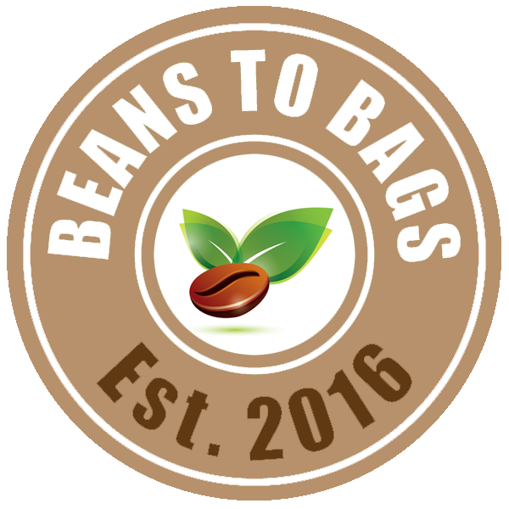

BEANS to BAGS EARN YOUR WAY
www.beanstobags.org

Earn Your Way
Avondale Middle School has partnered with Beans to Bags to create a unique way to help AMS Student earn their way on The Washington DC field trip. The Washington DC field trip is an outstanding experience that we would like to see participation for everyone.
Beans to Bags
Beans to Bags Roasting Company is a non-profit 501c(3) company run by Avondale High School students. The Beans to Bags coffee has superior flavor due to the high quality Arabica beans that are freshly roasted. Beans to Bags purchases green coffee beans, roasts the coffee at Avondale High School, and delivers the freshly roasted coffee to our customers within the peak freshness period. The hand signed bags with a roasting date signify quality and freshness.

Beans to Bags mission is to provide freshly roasted coffee from our roaster to our customer. In addition, we understand and value the importance of giving back to our community. 100% of the profits from Beans to Bags go to support Avondale youth in providing food and clothing for students in need, providing scholarships for those who participates in the entrepreneurship programs, and providing enrichment opportunities for students to go above and beyond.
How Does It Work?
Beans to Bags offers four types of coffee - Sumatra, Colombian, Costa Rican and Brazilian. Each bag retails at $12.00 for 12 oz bag. For every bag of coffee a student sell from February 1 through May 18th, 20120, the student will earn $5.00 towards the payment to the Travel Company.

To place an order, simply go to the sign up genius link, locate the delivery date, and select the type of coffee & coffee process. Make sure to write your first and last name on the comment box so you can the credit for the sales. All orders are due by Thursdays. Coffee deliveries to Avondale Middle School (AMS) are Mondays ONLY. Students will need to pick-up their orders at AMS during lunch on Mondays.

Payment
Beans to Bags accept cash and check. If pay by check, please make check payable to Beans to Bags. Submit weekly order money to AMS office by the Thursday you would like the following Monday delivery.

How to Sign Up?
If you are interested in participating in this fundraising opportunity, please fill out the Beans to Bags Earn Your Way Student Form via Google Drive (https://forms.gle/iGSFQWJJvsiV47zs8).

If you have any questions regarding Earn Your Way, please contact Bonnie Kakuda at bonnie@kakuda.org

